CSO Lab 5: Getting to Know the 8051 MCU
Question: Write a program that will perform a binary count from 00h to FFh.
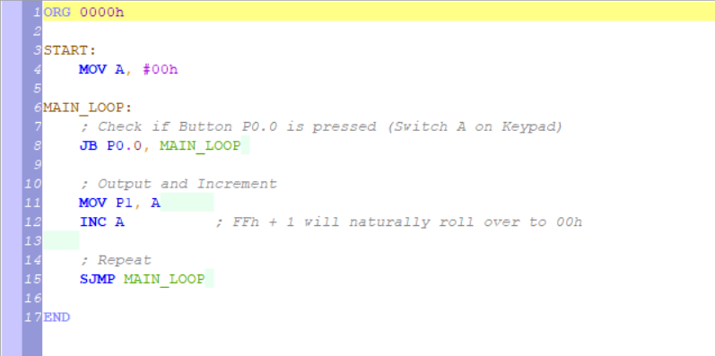

Code Explaination:
1. The Initialization
- ORG 0000h: This tells the microcontroller that the program starts at memory address 0000h. This is the standard "Reset Vector" where the 8051 looks for instructions when it first powers on.
- START: MOV A, #00h: This label marks the beginning of our setup. We move the value 00h (zero) into the Accumulator (A) register. This register acts as our "counter variable."

2. The Control Logic (The Button)
- MAIN_LOOP:: This is a label we use as a "return point" so the program can repeat indefinitely.
- JB P0.0, MAIN_LOOP: This is a Jump if Bit is Set instruction.
  - It looks at Pin 0 of Port 0 (P0.0).
  - In the 8051, pins are "High" (1) by default. When you click the switch in your keypad, it pulls the pin "Low" (0).
  - Logic: If the button is NOT pressed (pin is 1), it jumps back to MAIN_LOOP. It effectively "traps" the program here until you press the button.

3. The Output and Action
- MOV P1, A: Once the button is pressed, the program moves to this line. It copies the current value of the Accumulator into Port 1 (P1). This is what turns your LEDs on or off.
- INC A: This increments the Accumulator by 1.
  - Since the Accumulator is an 8-bit register, it counts from 00h (0) to FFh (255).
  - When it hits FFh and increments again, it naturally rolls over back to 00h automatically.

4. The Loop and Termination
- SJMP MAIN_LOOP: This is a Short Jump. It sends the program back to the MAIN_LOOP label to check the button again.
- END: This is a directive for the assembler to stop reading the file. It does not turn into a machine instruction.
Demo Video
https://drive.google.com/drive/folders/1rnfQfxfr03Xsfzd2DmIeLebdBVp3SIGy

